FIBONACCI SERIES WITHOUT RECURSION:

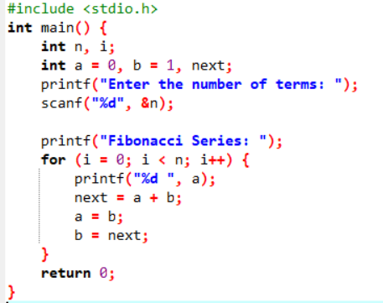

OUTPUT:

